**Line Detection:**

**Function Prototype:** 

**Parameters:** original image, edge image resulting from canny edge detection

**Description:** Detecting lines in image through the following steps, first we create an accumulator array. Then for each edge pixel we compute the line corresponding to it in the parameter space(slope and intercept) and increment their corresponding cell in the accumulator array. Then we identify the local maxima in the accumulator array according to some threshold.

**Return Value:** image with lines detected in it

**Sample input:**

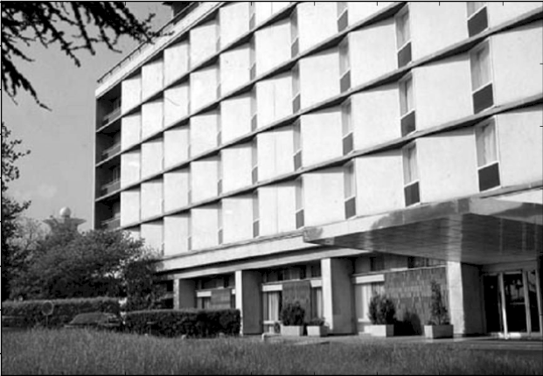

**Sample Output:**

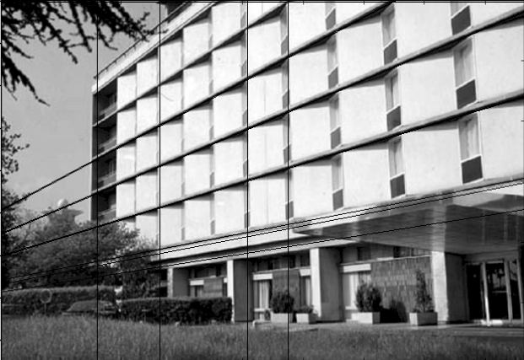

**Circle Detection:**

**Function Prototype:** 

**Parameters:** original image, edge image resulting from canny edge detection.

**Description:** Detecting circles in image through the following steps, first we create an accumulator array. Then for each edge pixel we compute the circle corresponding to it in the parameter space(radius and center) and increment their corresponding cell in the accumulator array. Then we identify the local maxima in the accumulator array according to some threshold.

**Return Value:** image with circles detected in it.

**Sample Input:**

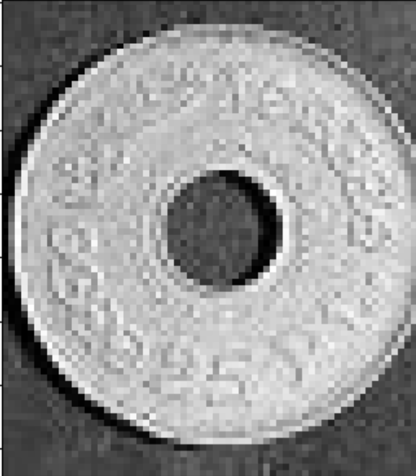

**Sample Output:**

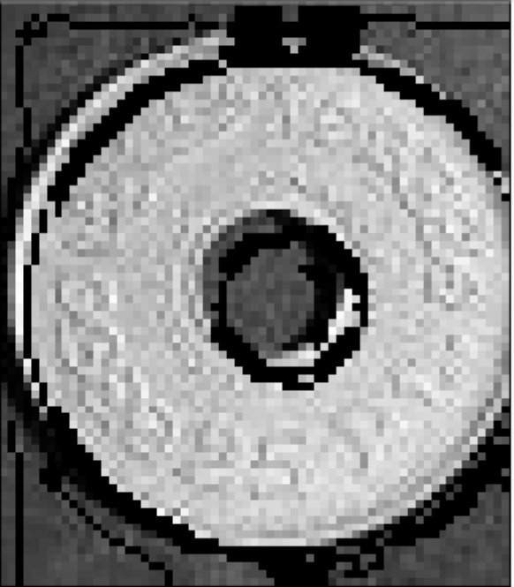

**Active Contour:** is a computer vision technique used for image segmentation, which is the process of dividing an image into multiple segments, each of which corresponds to a different object or region of interest within the image.

The basic idea behind the active contour algorithm is to iteratively deform a curve (known as the snake) so that it conforms to the edges or boundaries of the object being segmented. The snake is initially placed near the object of interest, and then it is allowed to evolve and adjust its shape until it reaches a stable position that best fits the object boundary.

The snake is modeled as a curve or a set of connected points that are influenced by both internal and external forces. The internal forces encourage the snake to maintain a smooth, continuous shape, while the external forces pull the snake towards the object edges. The external forces are typically computed based on image gradients, which provide information about the location and direction of edges in the image.

During the iterative process of curve evolution, the snake moves in the direction that minimizes the overall energy of the system. The energy function is a combination of internal and external forces that determine the behavior of the snake. The algorithm uses gradient descent to minimize the energy function and update the position of the snake.

Sample

